Case 2-A94- **Phoenicia-Sidon-Astarte-Terracotta-400 BCE**

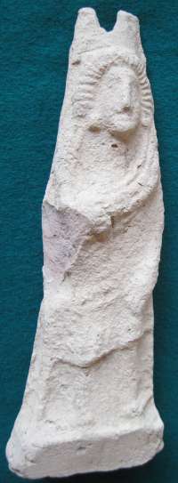 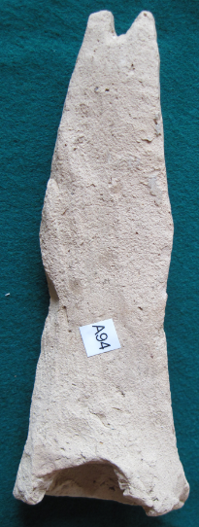 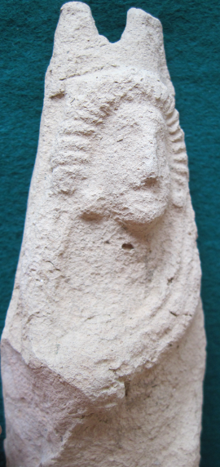

**Case No.: 4**

**Accession Number: A94**

**Formal Label: Phoenicia-Sidon-Astarte-Terracotta-400 BCE**

**Display Description:**

This Sidonian Phoenician figure of Astarte is the name of the Babylonianc mother-goddess, Ishtar.

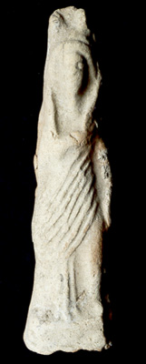

Unidentified, Standing Ishtar, no date, terracotta, 14.60 x 3.90 x 2.30 cm, MacKenzie Art Gallery, University of Regina Collection, gift of Mr. Norman MacKenzie. 1983-031-018

The MacKenzie Art Gallery permanent collection began with the bequest of Regina collector Norman Mackenzie in 1936.

The MacKenzie Art Gallery is located at 3475 Albert Street, Regina Saskatchewan, in the T.C. Douglas Building, situated in the South West corner of beautiful Wascana Park.

Between 1912 - 1936 he amassed an impressive collection of paintings and drawings of the Italian Renaissance, antiquities of Asia and the Middle East, and works by contemporary artists of his day, including James Henderson and Inglis Sheldon-Williams. MacKenzie's was the first art collection of note in Saskatchewan. Since then, the Gallery has acquired new works of relevance and value to the people of Saskatchewan. Many of the pieces have been donated by private collectors and prominent artists, others are purchased with acquisition funds raised in the community or from various government programs.

Today the collection includes more than 4,000 artworks including Canadian historical and contemporary works. Our collection of 19th and 20th century European works on paper is regarded as one of Western Canada’s finest. In recent years, photography, folk art and work by Aboriginal artists have also been a focus of our collecting. The permanent collection of the MacKenzie Art Gallery is held in trust, leaving a legacy of art for the people of Saskatchewan.

The MacKenzie Art Gallery’s mission is to serve our community by exhibiting, collecting, preserving and interpreting original works of art. As a public art gallery, we do not sell the works in our collection nor do we offer appraisal services to private collectors.

The preservation of the MacKenzie Art Gallery’s collection for future generations is an important part of the Gallery’s mandate. To do this, our Conservator works to minimize all causes of deterioration or damage during storage and display. Controlling light, heat, relative humidity and handling is essential for conservation. We occasionally assist with conservation and restoration for other public and private collections. Find out more about the [MacKenzie Art Gallery conservation services](http://mackenzieartgallery.ca/discover/art-conservation).

## [Discover](http://www.mackenzieartgallery.ca/discover)

* [Search the Collection](http://www.mackenzieartgallery.ca/discover/items)
* [Art Conservation](http://www.mackenzieartgallery.ca/discover/art-conservation)
* [MacKenzie Publications](http://www.mackenzieartgallery.ca/discover/publications)

## Share

[Tweet your thoughts >](http://twitter.com/home?status=Standing%20Ishtar%20%23yqr%20%40AtTheMAG%20http%3A%2F%2Fwww.mackenzieartgallery.ca%2Fdiscover%2Fitems%2F2603%2Fstanding-ishtar)

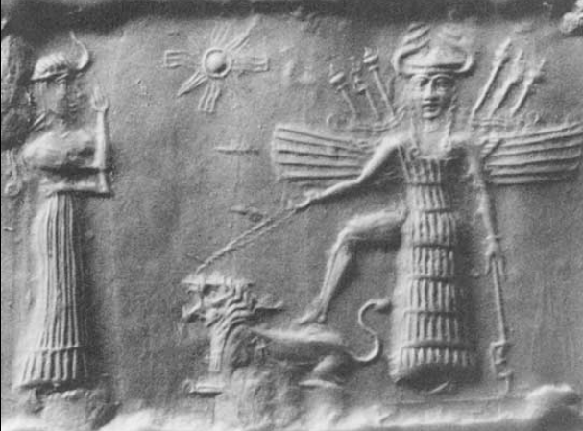 Her Ancient [Akkadian](https://en.wikipedia.org/wiki/Akkadian) [cylinder seal](https://en.wikipedia.org/wiki/Cylinder_seal) depicting Ishtar with her horned headdress resting her barefoot on the back of a lion while a female attendant stands in front of her paying obeisance, ca 2334-2154 BCE ([Wolkstein and Kramer 1983](https://en.wikipedia.org/wiki/Ishtar" \l "CITEREFWolksteinKramer1983), pp. 92, 193).

name appears in the Old Testament (I Kings xi. 5; II Kings xxiii. 13) as "Ashtoreth," a distortion of "Ashtart," made after the analogy of "Bosheth" (compare Jastrow, in "Jour. Bibl. Lit." xiii. 28, note). Solomon is said to have built a high place to her near his Jerusalem temple, because he had married a woman from Sidon who worshipped her. Solomon’s shrine to Ishtar was removed during Josiah's reform (I Kings xi. 5, 33; II Kings xxiii. 12) in which Astarte is called "the abomination of the Sidonians," because she was the chief divinity of Sidon and a main competitor of YHWH’s spouse (see Hoffmann, "Phönizische Inschriften," 57, and "C. I. S." No. 3). In Phoenician countries she was the female consort of Baal, and was worshiped with him by those Hebrews who at times became his devotees. This is proved by the fact that Baalim and Ashtaroth are used several times (Judges x. 6; I Sam. vii. 4, xii. 10) like the Assyrian "ilani u ishtarati" for "gods and goddesses."

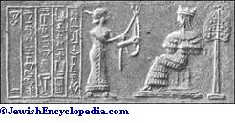Astarte as the Goddess of Love.(From Ball, "Light from the East.")

Astarte, wherever worshiped, was a goddess of fertility and sexual love. A trace of this among the Hebrews appears in Deut. vii. 13, xxviii. 4, 18, where the lambs are called the "ashtarot" of the flock. It is usually assumed that Astarte Worship was always a foreign cult among the Hebrews; but analogy with the development of other Semitic deities, like the Phoenician Baal, would lead to the supposition that Astarte Worship before the days of the Prophets may have somewhat prejudiced that of YHWH. The problem is a difficult one, the references to the cult in the Old Testament being so few and so vague. The reaction against Baal and Astarte, inaugurated by the Prophets, had a profound effect upon the moral life of Israel (see "Jour. Bibl. Lit." x. 72-91; Budde, "Religion of Israel," ch. ii-v.). Jeremiah (vii. 18; xliv. 17, 18) and Ezekiel (viii. 14) attest various forms of this worship in their time, which may refer to a direct importation from Babylonia. The sacrificial use of swine's blood (Isa. lxv. 4, lxvi. 3) may be a reference to a form of the cult similar to that known in Cyprus, where swine were sacred to Astarte ("Jour. Bibl. Lit." x. 74, and "Hebraica," x. 45, 47).

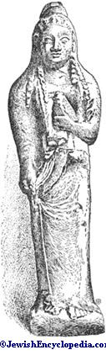Astarte with Dove.(From a Phenician terra-cotta in the Musee du Louvre, Paris.)

**Bibliography:**

**LC Classification:**

**Date or Time Horizon:**

**Geographical Area:**

**Map,**

**GPS Coordinates:**

**Cultural Affiliation:**

**Geographical Area:**

**Medium:**

**Dimensions**:   
**Weight:**

**Provenance:**

Derek Glover

PO Box 12309

Harlow

Essex

CM20 9NU

United Kingdom

**Condition:**

**Discussion:**

**References:**

* Roscher, Wilhelm Heinrich. 1977-1978. [**Ausführliches Lexikon der griechischen und römischen Mythologie**](http://www.worldcat.org/title/ausfuhrliches-lexikon-der-griechischen-und-romischen-mythologie-4-quadriformis-syzygia/oclc/180542047&referer=brief_results)**.** Hildesheim: Georg Ohlms.
* Barton, George Aaron, in Hebraica, ix. 133-165, x. 1-74;
* Barton, George Aaron. 1902. A sketch of Semitic origins: social and religious. New York; London: The Macmillan Company
* , ch. vii.;
* Wolkstein, Diane and Samuel Noah Kramer. 1983. Inanna: Queen of Heaven and Earth: Her Stories and Hymns from Sumer. New York: Harper and Row.

W. Robertson Smith, Religion of the Semites, Index.